
Dhaka International University
Lab Report details:
Lab Report Topic : Inheritance in Java
Lab Report No : 10
Course Title : Object-Oriented Programming Languages
Course Code : 0613-202

Submitted By: | Submitted To:
S M Nabil Ausaf  Roll: 01  Reg No : CS-D-91-23-124492 | Prof. Md. Abdul Based

Date of Submission: ‎04-‎Dec-‎24

Lab Report: Inheritance in Java

Objective:
The objective of this lab is to understand the concept of inheritance in Java and how it enables code reuse. Using the Person and Teacher classes, we will investigate how a subclass (Teacher) can inherit fields and methods from its superclass (Person) and extend its functionality. The aim is to print out the details of a Teacher object - name, age, and qualification - using inheritance.

Components Used:
- Java Programming Language: The code is in Java, which is a popular object-oriented programming language.
- Any Java IDE: To compile and run this code.
- Runtime Environment (JRE): This is required to run Java applications.

Theory:
Inheritance is one of the four basic principles of Object-Oriented Programming, the other three being encapsulation, polymorphism, and abstraction. It is a feature in which a class inherits the fields and methods of another class. The subclass can also add to or even override methods of the superclass.
- Superclass: This is the class from which other classes inherit. It may contain fields and methods that will be reused in the subclass.
- Subclass (Teacher): The class that inherits fields and methods from the superclass and can also add its own fields and methods.
- Method Overriding: A subclass can override methods of the superclass to provide specialized behavior.
In this example:
- The Person class has fields name and age, and a method displayInformation1() to display these details.
- Teacher class extends the Person class, adds the field qualification, and provides a method displayInformation2() to show information about the teacher-including the inherited fields from Person.

Code:
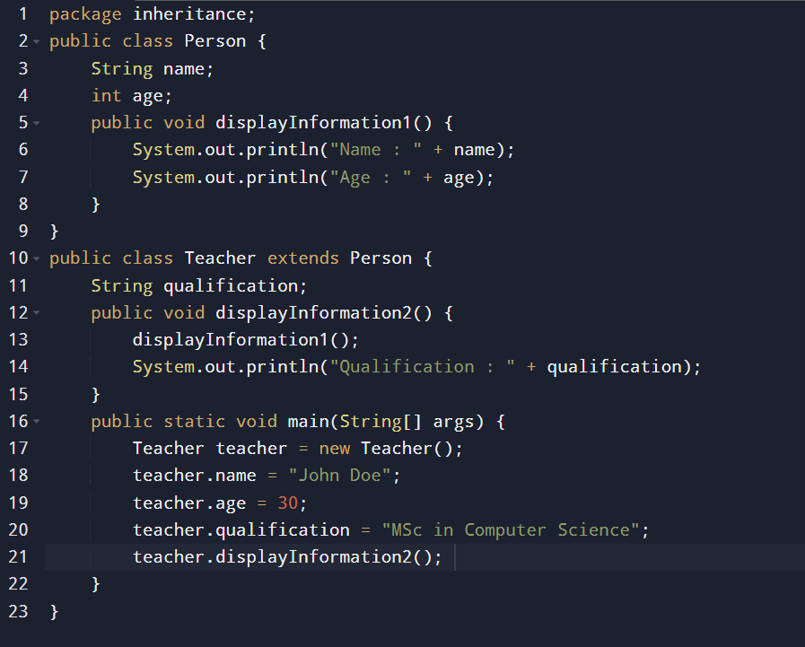
Problem-Solving Procedure:
1. Class Structure: First, we defined a class Person with the name and age fields along with a method displayInformation1() that shows those values.
2. Subclass Creation: Afterwards, we created a Teacher class extending the main class Person by adding a new field qualification to it. The Teacher class overrides the method displayInformation2() to show the teacher's name, age, and qualification.
3. Object Instantiation: In the main method, we instantiated a Teacher object, assigned values to the fields - name, age, and qualification - and then invoked the displayInformation2() method to print out the details.
4. Method Invocation: The method displayInformation2() in the Teacher class invokes the inherited method displayInformation1() to print out the name and age and then prints the qualification.

Output:
The output of the code when executed will be as follows:
Name : John Doe
Age : 30
Qualification : MSc in Computer Science
Explanation:
1. displayInformation2() is invoked on the object of the Teacher class, which in turn invokes displayInformation1() to display the name and age fields that are inherited.
2.Then, the method displayInformation2() prints the qualification field belonging to the Teacher class.
Hence, the output of the program is:
•The name of the teacher: John Doe.
•The age of the teacher: 30.
•The qualification of the teacher: MSc in Computer Science.

Discussion:
- Concept of Inheritance: This code illustrates the use of inheritance wherein the Teacher class is inheriting the fields and methods from the Person class. The subclass (Teacher) has access to the method displayInformation1() in the superclass Person for displaying the inherited name and age.
- Reuse of Methods: In the subclass, the use of the method displayInformation1() is an example of the power of method reuse with inheritance. Instead of writing similar logic to display the name and age, it invokes the inherited method.
- Extending Functionality: This is extended in the subclass Teacher, adding its own field qualification and its own method displayInformation2() that shows the teacher's particular information, while the inheritance in action permits the class to extend the functionality of its superclass.
Conclusion:
The lab demonstrates the concept of inheritance in Java. We used a simple example to show how a subclass can inherit from a superclass, allowing for code reuse and extension of methods. Here, the Teacher class inherited fields from the Person class, such as name and age, and extended its functionality by including the qualification field. This makes the code modular, less redundant, and better structured for real-world applications.
As can be seen, inheritance is one of the powerful features in object-oriented programming that makes the code more maintainable and enhances the efficient software design process. This example showed how, in Java, inheritance works and can model real-world relationships among classes.

